**Can spectral Data Capture Arctic Plant Biodiversity?**

Changes in plant communities are one of the most distinct responses to global climate change, yet we lack quantification of plant diversity and composition in the biome experiencing the highest rate of warming – the Arctic. Traditional methods of measuring biodiversity are both costly and limited in their spatial-temporal resolution. Increasing availability and remotely sensed spectral data could be used to monitor spatial-temporal changes of Arctic tundra vegetation. Yet, the feasibility of using spectral for even static local biodiversity evaluations still remains unclear. Using plot scale hyperspectral data, this study aims to investigate if spectral signatures can be used identify Arctic tundra vegetation types and predict biodiversity. Additionally, I identified what regions of the spectrum are most distinct between vegetation types and if dimensional reduction of data improves the spectral discrimination of vegetation type. This study shows that vegetation types can be identified by their spectral signatures, but that there is limited evidence of spectral-biodiversity relationships. While spectral signatures where variable between years and did not exhibit convergent trends, my results help establish highlight the challenges of sources of variability in hyperspectral data. By assessing the viability of using plot level spectral data to identify vegetation types and quantifying biophysical relationships, future remote sensing applications of remote sensing data can be facilitated and informed/improved.

**Table of Contents**

this should list all chapter headings and sub-headings. All should be numbered, e.g. 1. Introduction, 1.1 Background to the dissertation topic, etc.

**Acknowledgements**

I would like to thank Dr. Isla Myers-Smith for her guidance, insight, and advice at all stages of this dissertation. I am thankful for having her as a supervisor. A special thanks goes to Gergana Daskalova for her continuous support, thoughtful feedback, and expert advice in finessing my visualizations. I would like to thank all the remaining Team Shrub members for their feedback and insights that helped shape and improve my dissertation at all its stages. I would also like to acknowledge all those to who conducted fieldwork on Qikiqtaruk and collected the data, without which, this dissertation would not have been possible. I am thankful to Dr. Alison Beamish, for sharing her expertise when sorting through spectral measurments and her quick enthusiasm to help extract AVRIS data.

A final thanks goes Kimberley Schneidereit: without her continuous support, I would have not been able to have made it this far.

**List of abbreviations**

1. **Introduction**

Assessing biodiversity with efficient and scalable methods is increasingly essential as global change accelerates. The Arctic is a particularly vulnerable biome, undergoing the highest rates of climate warming (IPPC, 2019; Post et al., 2019). The Arctic is critical in the global carbon budget, holding twice the worlds atmospheric carbon in permafrost (McGuire et al., 2009; Schuur et al., 2008). Plants strongly influence carbon cycling and the energy balance of the ecosystem (Pearson et al., 2013). Understanding diversity and composition of vegetation communities is central to predicating environmental change and ecosystem function (Bjorkman et al., 2018). While systematic plot level surveys are the most accurate means of plant biodiversity assessment, the remoteness and high spatial heterogeneity of Arctic ecosystems significantly impedes traditional sampling strategies (Rocchini et al., 2010).The use of remote sensing could facilitate efficient assessment of biodiversity in real-time and at biome wide scales (Turner, 2014). Yet the biophysical relationships of remotely sensed signals to biodiversity are variable and challenging to interpret (Pettorelli et al., 2016). Plot level quantifications of biophysical relationships are needed to advance the use of remote sensing data for biodiversity assessments.

Vegetation types can be identified based on their unique spectral properties. Hyperspectral signature are a species’ or communities’ unique pattern of light reflectance. Variations in chemical composition, leaf traits, and canopy structure alter the absorbance and scattering of light, resulting in distinct reflectance values across the electromagnetic spectrum (Cavender‐Bares et al., 2017). Hyperspectral signatures have been found to be distinct to individual species (Schweiger et al., 2018), and between tundra vegetation types (Beamish et al., 2017). The variation in hyperspectral signatures (spectral diversity hereafter) can potentially capture more spectral complexity, improving identification of vegetation types (Wang, et al., 2018a). While vegetation types can be identified using spectral signatures, it remains unclear how spectral diversity relates to vegetation types.

Vegetation biodiversity can be estimated using spectral diversity. Spatial heterogeneous environments are predicted to have higher biodiversity, as there is increased availability of unique niches (Gaston, 2000). Spectral diversity increases with spatial heterogeneity and can be used as a proxy for biodiversity (spectral diversity hypothesis) (Heumann et al., 2015; Rocchini et al., 2010; Schweiger et al., 2018; Wang and Gamon, 2019). Yet, spectral biodiversity relationships are sensitive to environmental heterogeneity and variable between biomes (Gholizadeh et al., 2018; Rocchini et al., 2011). Environmental factors such as bare ground can also influence how spectral diversity needs to be assessed (Gholizadeh et al., 2018; Wang, et al., 2018a). It is unclear how spectral diversity relates to Arctic tundra vegetation richness and evenness.

The high dimensionality of hyperspectral data poses challenges to successfully identifying vegetation types (Somers et al., 2010; Song, 2005). Hyperspectral sensors measure reflectance in small bands of wavelengths that span the spectrum. Vegetation identification accuracy decreases once a threshold of included bands is passed (Hughes Phenomenon) (Gholizadeh et al., 2018). This is due to additional spectral bands being highly correlated to adjacent bands, while containing redundant information, as well as additional sensor noise (Delalieux et al., 2007; Somers et al., 2010). High data dimensionality reduces the potential to discriminate vegetation types based on their hyperspectral signatures.

Dimensionally reducing data can improve the spectral discrimination of vegetation types. Bands are selected that minimize intra-type variability and maximize inter-type differences (Jia et al., 2012; Song, 2005). Dimensional reduction of spectral diversity has been limited to principle component analysis (Dahlin, 2016) and convex hull area methods (Gholizadeh et al., 2018). An alternative approach is to use the InStability Index (ISI) to determine and select discriminative bands (Somers et al., 2010). The ISI, can additionally be used to identify key wavelengths that are most distinct between vegetation types and helps explain the biophysical origin of spectral differences between vegetation types (Beamish et al., 2017). Selecting distinct bands based on the ISI values can improve the spectral discrimination of vegetation types.

Quantifying biophysical relationships at plot scales establishes xxx Using drones, planes, and satellites high-resolution spectral data are becoming increasingly available at multiple scales (Lausch et al., 2016; Lee et al., 2015). This data could facilitate understanding spatial-temporal variability in vegetation compositions and biodiversity across large spatial scales. Yet, it is unknown how heterogenous physiological characteristics of Arctic vegetation types relate to observed spectral signatures. Furthermore, it is unclear how spectral diversity is influenced by species richness and evenness, and if spectral diversity can be used to predict biodiversity. Environmental factors such as bare ground also influence spectral diversity and need to be accounted for (Gholizadeh et al., 2018; Wang, et al., 2018a). Quantifying spectral-biodiversity relationship on plot levels provides fundamental information to facilitate the use of remotely sensed data for future environmental analysis and biodiversity monitoring.

**1.1 Study Objectives**

This study aims to use plot-level spectral data to investigate the patterns of spectral variability between two Arctic vegetation types. I address if vegetation communities can be identified based on their mean reflectance and spectral diversity. Through using the InStability Index (ISI), it is determined what regions of the electromagnetic spectrum are most distinct between Arctic vegetation types. To investigated if dimensional reduction of spectral data improves the spectral differentiation of vegetation types I conducted two band selections using i) manual band selection based on a priori assumption and ii) automated selection method using ISI values. Furthermore, I combined spectral signatures with point framing data, to evaluate if species richness and evenness can be estimated for Arctic vegetation communities and if bare ground influences spectral diversity. Using a principle component analysis, additional environmental factors, such as visible flowers and dead matter, cover type, and canopy density were visually evaluated in how they affect spectral properties.

**Ultimately, my study reveals xxx, suggesting xxx**

**1.2 Research Questions and Hypotheses**

**1: How do Arctic Vegetation types discriminate based on the spectral mean and spectral diversity of hyperspectral signatures?**

**H1**: Arctic vegetation types can be identified based on the mean of their spectral signature (H1a) and spectral diversity of their spectral signature (H1b). Spectral diversity will have a stronger correspondence with vegetation type (H1c). When ordinated, spectral signatures will discriminate among vegetation types (H1d) and year of measurement (H1e).

**H1o:** Arctic vegetation types do not differ based on the mean or variance of their spectral signatures, and do not discriminate when ordinated.

**2: Does band selection influence correspondence between spectral diversity and vegetation type.**

**H2.** Overall regions in the visible part of the spectrum (400-700nm) having higher correspondence with vegetation type than bands in the near infrared range (700-100nm) (H2a). Automatic band selection will result in the selection of a small but spectrally diversity subset of bands (H2b). Both manual and automatic band selection methods result in greater correspondence between spectral diversity and vegetation type (H2c).

**H3o:** There are no specific spectral regions that are best suited to discriminate vegetation types. Band selection does not visibly influence the correspondence between spectral diversity and vegetation type.

**3: How does spectral diversity relate to species richness, evenness, and bare ground?**

**H3:** Vegetation type will significantly affect spectral diversity (H3a). Higher spectral diversity will correspond with both increases in species richness (H3b) and species evenness (H3c), with evenness having the stronger relationship (H3d). Bare ground will have the strongest positive influence on spectral diversity (H3e).

**H3o:** Species richness, evenness, and bare ground have no effect on spectral diversity, with no visible relationship observed.

**4: Are closer measurements more similar than more distant measurements?**

**H4:** When tested for spatial autocorrelation, closer measurements will be more similar than more distant measurements (H4a), with no visible autocorrelation occurring across vegetation type areas (H4a).

**H4o:** There is no visible level of autocorrelation between measurements at any distance.

**5: Do plot and airborne spectra differ from each other? Does plot or airborne spectra show more variation among vegetation types?**

**H5:** Plot and airborne spectra do visually differ from each other (H5a), with plot spectra showing more variation both within vegetation types (H5b), and between vegetation types (H5c).

**H5o:** There is no visible difference between plot and airborne spectra, with neither accounting more variation among vegetation types.

**6: Can airborne remotely-sensed spectral diversity be used to identify vegetation types at the island scale?**

**H6:** Airborne remotely-sensed spectral diversity can be used to identify vegetation types at an island scale (H6a), and when visually compared, will correspond with an existent mapping vegetation type (H6b).

**H6o:** Airborne remotely-sensed spectral diversity cannot be used to identify vegetation types at an island scale, and when visually compared does not correspond with an existent mapping of vegetation types.

**1.2.1 Notes to Research Questions**

While attempted, Questions 5 and 6 could not be answered due to georectification issues. This work was preregistered with the Center for Open Science. For full preregistration visit <https://osf.io/7utng>

*Note: For improved clarity, Questions 2 and 3 where rearranged. Bare ground was renamed soil-background.*

**1.3 Predictions**

Figure 1.3 depicts a conceptual diagram of H1 and H3 and my predictions.



**Figure 1.3** Conceptual diagram of hypotheses one and three with predicted results.

1. **Methods**

**2.1 Study Site**

All data used for analysis were collected through fieldwork of Team Shrub members on Qikiqtaruk-Herschel Island (QHI), located at 69.34°N, 138.55°W in the north western Yukon, Canada (Figure 2.1). QHI lies 5 km from the mainland in the Beaufort Sea and has a total area of 110 km2, measuring 13 x 15 km. Being a high latitude site, QHI experiences seasonal extremes in solar radiation and temperatures, ranging from -35°C in winter to 5°C in summer, the mean annual temperature being -9°C (Obu et al., 2017). This region of the Arctic is undergoing rapid climate and environmental change (Assmann et al., 2018; Myers‐Smith et al., 2019). QHI is composed predominantly of unconsolidated fine-grain marine sediment (Obu et al., 2017). Organic cryosols cover the extent of the island, with other soils only present at beaches.

**ADD HI-RES MAP!!!!!!!!!!!!!!!!!!!!!!!!!!!!!!!!!!!!**

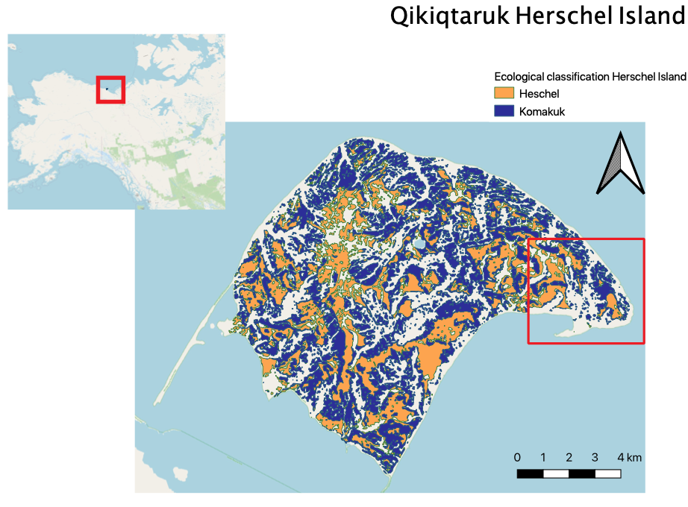

**Figure 2.1.** Extent of Herschel and Komakuk vegetation types across Qikiqtaruk-Herschel Island, with the inset map depicting the location within North America. The extent of the red square on QHI indicates the study site, Collison Head, and the location the long-term monitoring plots from were spectral measurements were taken (data source: vegetation classification (Obu et al., 2017))

QHI is floristically composed of predominantly lowland Arctic tundra plant communities, consisting of seven discrete vegetation type (Obu et al., 2017). Only the two dominate vegetation types, Herschel and Komakuk, were investigated in this study. Herschel vegetation type is characterized by relatively undisturbed moist acidic tussock tundra with an expanding willow canopy layer (Myers-Smith, Hik, et al., 2011). Komakuk is composed of herbaceous and graminoid tundra, subjected to cryoturbation and surface disturbances (Myers-Smith, Hik, et al., 2011; Myers‐Smith et al., 2019). Each vegetation has 6 established 1 m 2 plots being monitored since 1999, according to ITEX methodology and are arranged randomly along 50m transects (Molau, 1995).

* 1. **Data Acquisition**

Figure 2.2 is a workflow diagram outlining key steps in data acquisition, manipulation, analysis, and visualization.

**Insert figure**

**2.3 Plot Scale Spectral Data**

All analysis conducted relied on plot level spectral data collected over the 2018 and 2019 field season. Spectral data in both years were collected from 1x1m long-term monitoring plots that exist in Herschel and Komakuk vegetation types (6 plots each). To capture within plot spatial heterogenetic, long-term monitoring plots were partitioned into 9 subplots (3x3 m grid) from which replicate measurements were taken. In 2018, each subplot was reflectance and was measured at 9 distinct points, while in 2019, spectral measurements were only duplicated at each subplot. In 2019 Additional spectral measurements were taken in areas exhibiting typical Herschel or Komakuk compositional features. These were grouped as mixed, as plots were alternatively sampled and could not be assigned to their original vegetation type. Point measurements were aggregated at plot level to represent the spectral signature of each community. Spectral measurements were taken during the end of the peak season phenological phase (04th August in 2018 and 30th & July in 2019). Solar radiance conditions at the time of spectral measurements varied between the years - 2018 being overcast and 2019 being sunny. Measurements were calibrated for downwelling radiance, using a white micasense plate. Spectral measurements were taken using two different spectrometers, with 2018 data having a higher spectral resolution. The obtained reflectance values were subset to 400–985 nm, filtering sensor noise present at the spectrometer’s limits of detection range.

Add plot GPS

**xxx. airborne remotely sensed spectral**

Airborne visible/infrared imaging spectrometer AVIRIS sensor data were taken by NASA during the 2019 field season. Airborne remotely sensed hyperspectral data span across Qikiqtaruk-Herschel Island and where taken on two different dates (2nd July 2019 & 27th July 2019) at spatial resolution of 5m per pixel. Using spatial extent data of vegetation types (Obu et al., 2016), 50 plots within each vegetation type could be assigned from which to extract spectral data. Due to navigation issues during data collection, airborne spectral data had unresolvable georectification issues. Therefore I was not able to continue and finish my analysis for research questions 5 and 6.

**2.4 Spectral Diversity Metric**

The coefficient of variation (CV) was used as the spectral diversity metric (Rocchini et al., 2010; Wang, Gamon, Emmerton, et al., 2016) (equation 1). CV is an expression of the spectral diversity of all the individual spectral measurements within a single plot.

**(1)**

$${CV}_{(plot) }= \frac{\sum_{λ1}^{λ2}{(\frac{ σ(ρλ)}{μ(ρλ)}})}{number of bands}$$

*ρλ is the reflectance at wavelength λ.* σ*(ρλ) and μ(ρλ) are the standard deviation and mean value of reflectance at wavelength λ across all the pixels in one plot. (Wang, Gamon, Cavender-Bares, et al., 2018b).*

**2.5 Plot Level Point Framing Data**

At each of the long-term monitoring plots, vegetation compositional, structural, and phenological properties were collected using a point-framing vegetation surveying methods. Point framing involves partitioning each plot is into 100 1cm2 cells and systematically recording species, tissue type, and statues (standing/dead). From point framing data, I calculated per plot, the biodiversity metrics richness and evenness using percentage cover of each species. Additional factors likely to influence spectral diversity where also calculated. These included bare ground, total vegetation cover, dead tissue, flowing tissue, as well as total graminoid and shrub cover. Only relevant observation of the top canopy layer where included, as sub-levels do not directly influence reflectance (Gholizadeh et al., 2018).

**Cite ITEX methodology, add point framing image**

**2.6 Spectral Band Selection**

**2.6.1 Manual Band Selection**

I conducted a manual band selection through identifying relevant spectral regions based on a literature review of other studies featuring spectral analysis of Artic vegetation (table 2.4.1). I synthesized band sections of multiple sources and adapted them based on *a priori* assumption of the predicted biological significance spectral regions. Previous work indicates that regions in the blue, green peak, red, and middle of red-edge (680-725 nm) regions of the spectrum are particularly distinct between vegetation types. (Beamish et al., 2017; Bratsch et al., 2016; Buchhorn et al., 2013; Huemmrich et al., 2013; Liu et al., 2017).

*Table 2.4.1- The wavelengths included in supervised band selection and relevant biological significance.*

|  |  |  |
| --- | --- | --- |
| Wavelength | Spectral Region | Biological significance |
| 430-450 | Blue | Chlorophyll & carotenoid absorption |
| 545-555 | Green | Green reflectance peak |
| 660-680 | Red | Max absorption of chlorophyll |
| 700-725 | Red | Middle of red-edge transition |
| 745-755 | NIR | End of red-edge transition |
| 920-985 | IR | Vascular plant structures & water absorption |

**2.6.2 Automatic Band Selection**

An additional automatic band selection for dimensional reduction was conducted. While improving classification accuracy, manual band selections do not filter spectral noise and are susceptible to removing bands that contain important information for vegetation type discrimination (Gholizadeh et al., 2018). Therefore, I used Stabile Zone Unmixing (SZU) to automatically select a subset of bands. SZU, is a type of spectral mixture analysis that aims to provide robust and automated band selections to yield the optimal subset of bands for discriminating vegetation types. This is achieved through calculating the InStability Index (ISI) (Somers et al., 2010), a ratio index based on reflectance of each band across the entire measured spectrum and identifies bands (Equation1). The ISI helps identify bands that are least sensitive to spectral variance, while maintaining comparably higher intertype differentiation.

**(1)**

$${ISI}_{i}= \frac{1.96(σ_{1,i}+σ_{2,i})}{{| R}_{mean,1,i}-R_{mean,2,i} | }$$

*Rmean,1,i and Rmean,2,i are the mean reflectance values of each vegetation type and σmean,1,i and σmean,2,i are the standard deviations of the reflectance values (Somers et al., 2010).*

ISI values represent the intra-community spectral variance when compared to inter-community differences. A lower ISI indicates that a band is better at discriminating vegetation types (Beamish et al., 2017). Comparing ISI values across the entire spectrum, identifies the spectral regions best suited to discriminating Artic vegetation types. Furthermore, specific wavelengths and the associated biophysical features can be identified (Beamish et al., 2017). This helps explain the origin spectral differences between vegetation types.

The computed ISI values were used as a selection criterion for the final band selection. A three-band moving window was used to identify and select local ISI minima. Local minima selection enables the automated and flexible selection of bands across the entire spectrum and does not exclude bands from variable spectral regions (Beamish et al., 2017). I conducted an additional post hoc automated band selection exclusively using 2019 measurements, as these had more distinct endmembers, cited to be essential to providing accurate and appropriate band selections (Somers et al., 2010; Song, 2005). This helped assess the robustness of the automated band selection. The theoretical optimum number of bands to discriminate bands was found by calculating DISI,  the amplitude at which estimated accuracy decreaseswith the inclusion of each additional bands (For full methods see appendix xxx)

**2.7 Statistical Analysis**

I conducted my statistical analysis using R (v.3.6.2). No hierarchical structure existed, as spectral mean and diversity are aggregated on a plot level. Therefore, I used a multiple linear regression model (MLRM) to conduct my statistical analysis.

Normality and homoscedasticity were assed using Q-Q plots. To test how vegetation types influence spectral signatures, separate multiple linear regression models were used for spectral mean and spectral diversity. The same models were used to evaluate H2c, with spectral diversity calculated using the subset of bands that were selected in manual and automatic band selections.

*Spectral mean ~ vegetation type + year*

*Spectral diversity (CV) ~ vegetation type + year*

The following multiple linear regression model was used to quantify how species richness, evenness and bare ground affect spectral diversity. Interaction factors were included between vegetation type and each continuous variable.

*Spectral diversity (CV) ~ vegetation type + year +*

*(vegetation type *richness) +*

*(vegetation type *evenness) +*

*(vegetation type *bare ground)*

Variables in linear models where considered to be significant at p-value with an alpha level of 0.05 and if standard error around

1. **Results**

**3.1 How do Arctic vegetation types discriminate based on the mean reflectance and spectral diversity of hyperspectral signatures?**

**3.1.1 Spectral Signatures by Vegetation Type**

When comparing vegetation types, Herschel plots had lower mean reflectance and higher spectral diversity than Komakuk plots. MLRM predicted that Herschel vegetation had a lower mean reflectance than Komakuk (estimate HE=0.18; estimate Herschel=0.25)(p=0.02, SE=0.03, n=26)(Appendix). Herschel type had a higher spectral diversity than Komakuk type (estimate HE=0.13; estimate KO=0.05) (p=0.02, SE=0.02, n=26).

There is evidence that vegetation types can be identified based on their mean reflectance and spectral diversity, implying an acceptance of H1a. and H1b.. Vegetation had greater predicted differences based on their spectral mean, implying a rejection of H1c.



**Figure 3.1.1 Panel Plot Comparing Mean Reflectance and Spectral Diversity (CV).** Panel A and B: The mean reflectance and spectral diversity between different vegetation types. Red and Green points correspond with measurements from 2018 and 2019 respectively. C and D: Mean reflectance and spectral diversity across the spectrum of each vegetation types in each year. Background colors correspond to each region of the spectrum; blue 400-500 nm, green 500-600 nm, red 600-680 nm, near infra-red 680-800, infra-red 800-985.

**3.1.2 Spectral Signatures by Year**

Predicted mean reflectance and spectral diversity values were greater in the 2019 measurements, mean reflectance (estimate=0.07) (p=0.03, SE=0.03, n=26) spectral diversity (estimate=0.16) (p<0.001, SE=0.2, n=26) (Appendix). When comparing between years, vegetation types had reversed trends in terms of mean reflectance, Herschel has a higher mean reflectance than Komakuk in 2018 and lower mean reflectance in 2019.

**3.1.3 When ordinated, do spectral signatures discriminate among vegetation type and year?**

The spectral discrimination of vegetations types in an ordination approach was only possible for the 2019 measurements. Here, Herschel and Komakuk had a sufficiently large distance in spectral feature space and greater inter-group differentiation than intra-group variation. When ordinated, spectral signatures clustered primarily by year (along the PC1 axis) with 2018 Heschel and Komakuk groups overlapping. Mixed vegetation spectral signatures did not discriminate into two groups corresponding with 2019 Herschel and Komakuk measurements, despite being selected based on exhibiting distinct compositional characteristics of either vegetation type.



**Figure 3.1.3 PCA of Spectral Signatures Grouped by Vegetation Type and Year.** Spectral signatures of each plot were arranged in ordinal space according to mean reflectance and spectral diversity. Large points indicate the center of each group. PC1 accounted for 54.7% of variance and PC2 46.3%

Spectral signatures were also ordinated separately by year (Appendix xxx). General trends remained relatively consistent, with 2019 measurements showing less differentiation.

**3.2: Does band selection influence correspondence between spectral diversity and vegetation types?**

**3.2.1 What regions of the spectrum best discriminate vegetation types?**

I identified the red region of the spectrum to best discriminate vegetation types, based on mean ISI (Table 3.2.1). This implies acceptance of H3a, where visible regions of the spectrum were predicted to have higher correspondence with vegetation type. Despite having a relatively small inter-type difference in mean reflectance, single bands that had green-red transition had the lowest ISI values and were the most informative for discriminating vegetation types (figure 3.2.1). The two selected bands with the lowest ISI values, 573 and 599 nm correspond with anthocyanin absorption (Beamish et al., 2017; Merzlyak et al., 2008). The red-edge transition (~690 - 740 nm) had a relative peak in ISI values at 718 nm, which corresponds with the point of transition from chlorophyll adsorption to canopy structure scattering (Asner and Heidebrecht, 2002; Daughtry, 2000). The NIR region exhibited a plateau with relatively low and consistently stable ISI values from 750-800 nm. The blue and IR regions respectively were the least discriminative, as well as the most variable, despite sensor noise at the limits of the spectrometer detection range being removed. The additional band selection using more spectrally distinct endmembers in the 2019 data (**Appendix** xxx), had visual correspondence with the full band selection using 2018 and 2019 data.

**Table 3.2.1** Summary of ISI values by region, and breakdown bands selected. A lower ISI indicates that a band is better at discriminating vegetation types

|  |  |  |  |  |
| --- | --- | --- | --- | --- |
| Region | Total ISI | Mean ISI | Number of bands selected |  |
| Blue | 1161 | 19 | 5 |  |
| Green | 1044 | 17.1 | 2 |  |
| Red | 799 | 16 | 3 |  |
| NIR | 1326 | 17 | 3 |  |
| IR | 2218 | 18.2 | 11 |  |



**Figure 3.2.1 InStability Index (ISI) of bands across the spectrum.** ISI values indicate how well bands discriminating vegetation types, with low values being more discriminative. Clear dots along the plotted ISI and the corresponding rugs indicate bands selected, via local minima selection. Background colors correspond to each region of the spectrum; blue 400-500 nm, green 500-600 nm, red 600-680 nm, near infra-red 680-800, infra-red 800-985.

**3.2.2 What bands were selected following automated band selection?**

Automatic band selection yielded a dimensionally reduced, but spectrally diverse subset of bands, indicating an acceptance of H3b. Yet, there was a proportionally high inclusion bands IR and blue regions. The applied three-wavelength moving window for minima selection unequal distribution of selected bands, due to regionally differences ISI variability.

Plotting cumulative D­ISI, I value show the amplitude at which estimate accuracy deceases with the inclusion of each additional bands (figure 3.2.2). I found a global maximum at 3 selected bands, which indicates the theoretical optimum number of bands. Each further additional band included provides less information relative to introduced variability and reduces the spectral discrimination of vegetation types (Somers et al., 2010). The moving window minima selection selected 25 bands



**Figure 3.2.2 D­ISI, I Accumulation by Number of Bands Selected.** D­ISI, I is the amplitude at which estimate accuracy deceases with the inclusion of each additional band. The red dashed line indicates the global maximum at selected bands. This is the theoretical optimum number of selected bands to best discriminate Herschel and Komakuk vegetation types based on their spectral signatures. The dotted black line at 25 indicates the number of bands selected using the three-band moving window minima selection. (full methods; appendix xxx)

**3.2.3 Does band selection result in greater discrimination between vegetation types based on spectral signatures?**

I found that band section in not result in greater differentiation between vegetation types based on their spectral signatures, implying a rejection of H2a. Manual and automatic selection included 24 and 25 bands respectively.

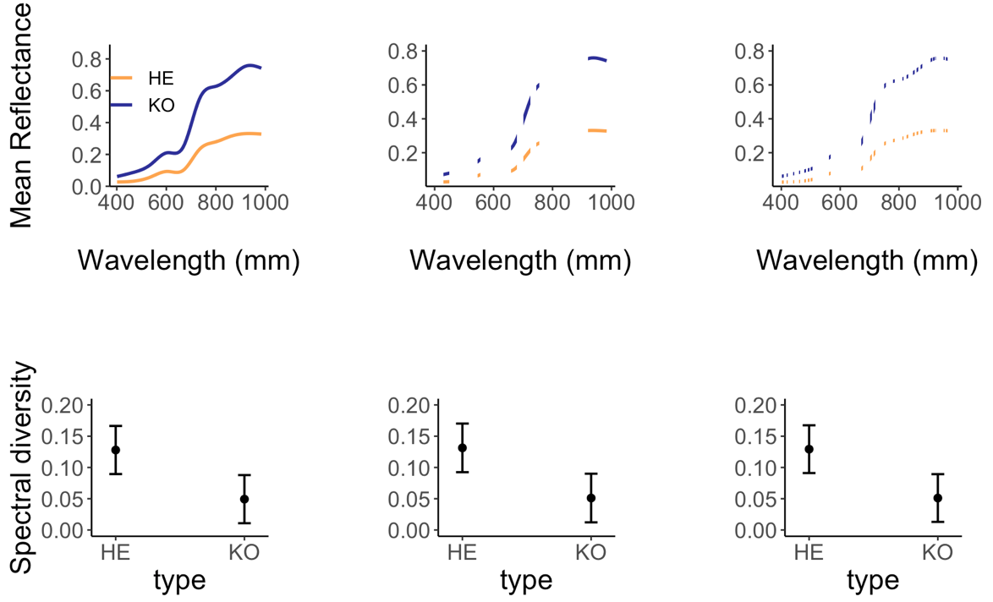

**Figure 3.2.3 Comparison of predicted mean reflectance and spectral diversity.** The first row (A,B,C) is a visual representation of the subset of bands in each model. Each column corresponds with one set of bands, with (A,D) being the full spectrum, (B,E) manual band selection, and (C,F) automated band selection.

**3.3 How does spectral diversity relate to species richness, evenness, and bare ground?**

**3.3.1 How does spectral diversity relate to richness and evenness?**

Spectral diversity did not have a consistently significant positive correspondence with either species richness or species evenness implying a rejection of H3b andH3c (Figure 3.4.1, Appendix). Only species richness in Herschel vegetation had a significant relationship with spectral diversity (estimate=0.05, SE=0.02, p-value=0.02, n=11).

**3.3.2 How does bare ground relate to biodiversity?**

I did not find a relationship between spectral diversity bare ground in either vegetation types (Figure 3.4.1, Appendix). This implies a rejection of H2d and H2e which predicted a strong positive correspondence between bare ground and spectral diversity. Increased bare ground did tend to result in lower spectral diversity, but large errors were associated with predicted values.

**Change to Nrow2!!!!!!!**



**Figure 3.3.2 Multiple Linear Regression Models Predicting Spectral Diversity (CV).** Spectral diversity **(**A) increases with richness in Herschel vegetation, (B) does significantly correspond with evenness (C) tends to decrease at higher soil background. Herschel vegetation types estimates are in yellow and Komakuk in blue, with ribbon representing the upper and lower bounds of the 95% confidence intervals. Plotted points represent computed spectral diversity estimates. Herschel type, n=11, Komakuk type, n=10)

**3.3.3 How is spectral diversity influenced by additional environmental factors?**

When spectral signatures were ordinated with additional environmental factors derived from point framing data, total cover had close positive correspondence with spectral diversity (CV). Total cover incorporates both canopy and sub-canopy vegetation layers and indicates greater vegetation density. Shrub cover, evenness and partial richness were also correlated. Aside from the previously tested factor bare ground, flowering tissue was directionally opposed to spectral diversity.

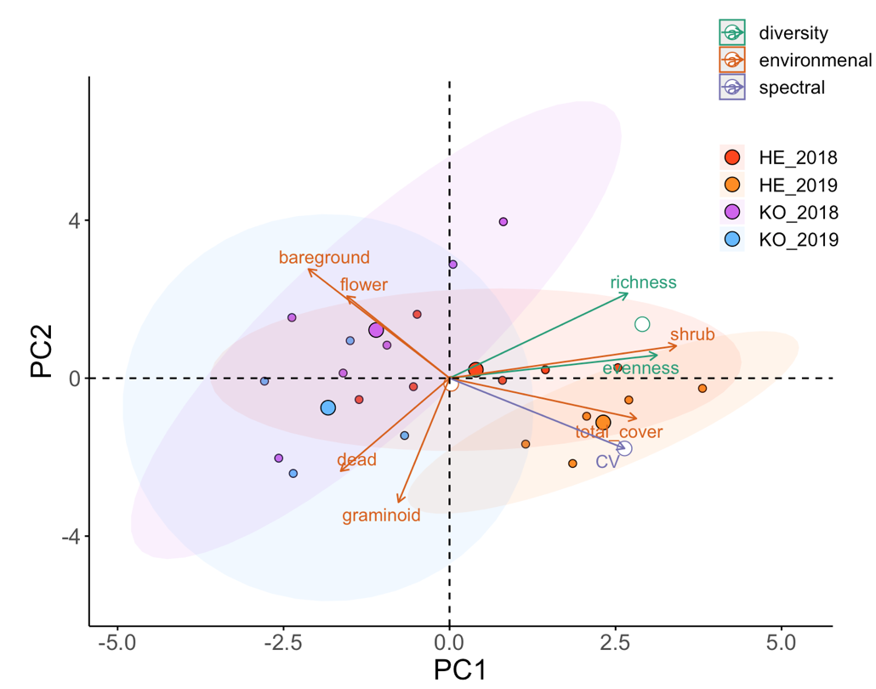

**Figure 3.3.3 Ordination of Spectral Diversity (CV) and Environmental Factors.** Groups were colored with red indicating Herschel 2018, yellow Herschel 2019, purple Komakuk 2018, blue Komakuk 2019. Factors where colored by type, green being diversity indices, orange environmental factors, and lavender spectral properties. **Dead, graminoid, shrub, and reproductive tissue represent plot cover at canopy layer (visible when looking from above)**. Mean reflectance is denoted as Spec_mean; spectral diversity as CV. PC1 accounted for 39% of variance and PC2 27%.

**3.4 Are closer measurements more similar than more distant measurements?**

All spectral measurements within one vegetation type exhibited degrees of spatial autocorrelation. The distance to the sill indicated uncorrelation of measurements 20 meters (Figure 3.4). Plots of each vegetation type were arranged along transect, with a maximum distance of 50 m between the first and last plot, meaning some spatial autocorrelation is always present. **The nugget to sill ratio indicates what percent of the total observed variance is observed at distances smaller than the minimal distance between two plots. With nugget to sill ratio of 70% of variance between measurements can be attributed to distance (cite).**

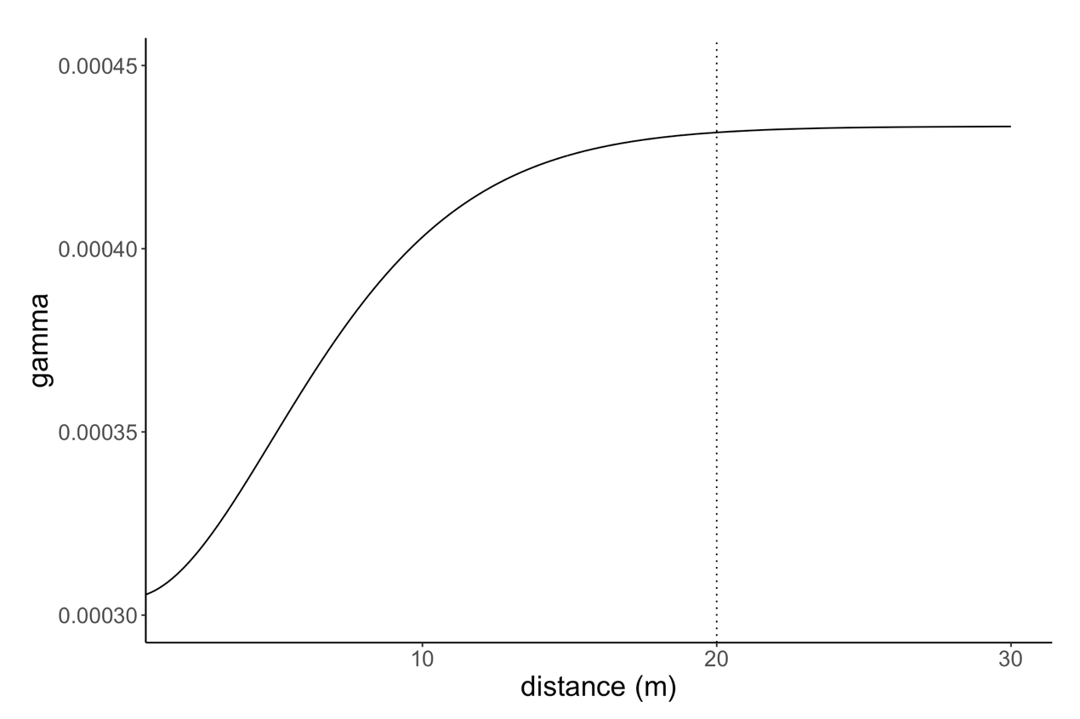

**Figure 3.4 Variogram of Spectral Measurements.** Nugget at 0.00031; sill at 0.00043

**4. Discussion**

**4.1 Key Findings**

I found that dominate vegetation communities do have distinct spectral signatures, which they can be identified by. Mean reflectance had a larger correspondence with vegetation type than spectral diversity, suggesting an acceptance of H1a-H1b, and a rejection of H1c. Both spectral mean and spectral diversity was greater in 2019 vegetation types. In an ordination approach, vegetation types discriminated by year and only partially by vegetation type, resulting in a rejection of H1d and acceptance of H1e. Spectral zone unmixing showed that overall bands from the green-red transition regions (570-670 nm) of the visible spectrum are the most distinct between vegetation types, resulting in an acceptance of H2a. Dimensional reduction, through automated band selection provided a small but spectrally diverse subset of bands, accepting H2b. Both manual and automatic band selections did not visually improved discriminating vegetation types based other their spectral signatures, resulting in a rejection of H3a. Spectral diversity did not have a consistent positive relationship with species richness, species evenness, and bare ground, and a rejection of H3b – H3e.

My results indicate Arctic tundra vegetation types can be successfully identified by their spectral signatures, yet large variance existed between years of measurement. The incongruence between my observed spectral-biodiversity relationships and previous literature highlights the challenges and of using hyperspectral data for biodiversity predications.

**4.2 How do Arctic vegetation types be discriminate, based on the mean and variance of hyperspectral signatures?**

**4.2.1 Spectral Signatures between Vegetation Types**

My results indicate vegetation types show greater discrimination based on their mean reflectance. I anticipated that spectral diversity would have larger correspondence with vegetation types, as spectral diversity can account for complexity of reflectance patterns across the spectrum (Wang, et al., 2016; 2018). Herschel and Komakuk vegetation types did significantly differ in their spectral diversity, but mean reflectance had a stronger relationship with vegetation type.

Komakuk vegetation has greater mean reflectance, however the vegetation does not correspond with the biophysical characteristics associated with higher reflectance. Increased canopy complexity and vegetation density predominantly amplify reflectance in the NIR and IR regions of the spectrum (Asner and Martin, 2009; Ollinger, 2011). Therefore, Hershel vegetation, characterized by shrubs undergoing canopy gradual expansion would be expected to have greater mean reflectance. Yet, Komakuk plots dominated with gramonid species with less canopy cover were found to have greater mean reflectance. When ordinated it was found that standing dead cover slightly correlated with increased mean reflectance but was unlikely to account for the large increase in spectral mean. It is possible that other factors not related to Komakuk vegetation physiology resulted in the observed high differences in spectral measurements.

Vegetation types may show greater discrimination by spectral diversity during senescence. At vegetation senescence, differences in chemical properties, such as photosynthetic pigmentation are most prominent (Beamish et al., 2017). Pigmentation influences reflectance across multiple spectral regions, resulting in vegetation types showing less differentiation based on their mean reflectance (Wang, et al., 2018; 2018b). Spectral diversity accounts for variation across spectral regions and would be a better metric for distinguishing vegetation types (ibid). Quantifying how mean reflectance and spectral diversity vary between phenological phases, could provide insight into when vegetation types are most distinct in their spectral diversity.

**4.2.2 Spectral Signatures between Years**

Lower between vegetation type differentiation of spectral signatures in 2018 may be attributed to inconsistencies in weather conditions. At Arctic sites, persistent cloud cover, variable solar irradiance, and short phenological phases impact measurement quality and the ability to replicate measurements between years (Beamish et al., 2017). Increased cloud cover during 2018 measurements likely confounded spectral data, resulting in less spectral differentiation between vegetation types in 2018 (Hope et al., 1993). While measurements where calibrated for solar irradiance conditions, this only standardizes reflectance and does not compensate for altered patterns of reflectance at low irradiance. Cloud cover is likely to have reduced in 2018 measurements capturing less variance between vegetation types.

Phenology at the time of measurements may have resulted in lower mean reflectance values in 2018. Short growing seasons at high latitudes result in rapid shifts in phenology (Bjorkman et al., 2015). Measurements occurring 6 days earlier in 2019 could result in vegetation still exhibiting typical maximum canopy characteristics, while in 2018 vegetation would be beginning to senescence. Pigmentation concentration, and canopy density decrease during senescence, resulting in lower mean reflectance (Chavana-Bryant et al., 2017; Wang, et al., 2016b). Lower mean reflectance of both vegetation types in 2018 relative to 2019, may be attributed to measurements occurring during early senescence.

Exploratory analysis indicated that potential variations in wetness are unlikely to have influenced spectral signatures between years. Previous work has found that temporal variations in wetness influence measurements (Wang, et al., 2016) Wetness increases absorbance in the red and NIR regions of the spectrum, resulting in a lower mean reflectance (Buchhorn et al., 2013; Liu et al., 2017). Using point framing data, I identified two plots, which had records of standing water, indicating higher wetness. When ordinated I observed no visual trend of wetness influencing spectral signatures, as wet plots in 2018 had both the highest and lowest mean reflectance. This indicates that seasonal weather variation influencing wetness are unlikely to explain the spectral difference in between years.

Deviations in levels of replication may have contributed to higher mean reflectance and spectral diversity in 2019. Reduced replication could have resulted in obtaining an unrepresentative sample including greater small-scale heterogenic features. Factors such as dry soil, small stones, and lichens can increase mean reflectance (Asner, 1998; Chuvieco et al., 2002). Komakuk plots have increased bare ground visibility and an increased chance of including high reflectance heterogenic features. Yet a post hoc MLRM found that bare ground has a non-significant slightly negative relationship with spectral mean (Appendix xxx). Therefore, Unrepresentative sampling of small-scale heterogenic features is likely not connected to variability in spectral signatures.

**4.2.3 Identifying Vegetation by Spectral Signatures in Ordination**

I found that when ordinated only spectral signatures from 2019 Herschel and Komakuk plots visually discriminated. The lack of inter-type differentiation between 2018 plots, and strong intra-type differences between 2018 and 2019 suggests uncertainty in how well spectral signatures can be used to identify vegetation types.

Ordination could not discriminate mixed vegetation plots. When ordinate, I expected that mixed plots would cluster into two groups, each corresponding with one vegetation type. Mixed plots were selected based on visually exhibiting characteristic Herschel or Komakuk features. I found that overlap between Komakuk plots occurred, but that mixed Herschel plots occupied their own region in ordinal space. This is possibly due to the mixed Herschel plots having regional heterogeneity in vegetation compositional structure or phenotypic appearance (Asner, 1998). Alternatively, environmental factors may have had greater influence on spectral signatures than vegetation type. (Appendix). This suggests that at regional scales additional sources of heterogeneity may reduce spectral signatures distinctness, making vegetation types more challenging to discriminate. In ordination approaches, discrimination of vegetation types is dependent on spatial factors.

**4.3 Does band selection influence correspondence between spectral diversity and vegetation?**

**4.3.1 What regions of the spectrum best discriminate vegetation types?**

I found that bands in the green-red transition region (570-670 nm) were the most distinct between vegetation types. This indicates that absorption of light caused by pigmentation are more distinct between vegetation types, than canopy complexity and structure. At 573 nm was the most distinct between types and corresponds with the absorbance of anthocyanin (Merzlyak et al., 2008). Leaf anthocyanin accumulation occurs as a response to temperature and light stress or vegetation entering senescence (Landi et al., 2015; Ollinger, 2011). Yet, there is no indication of either of these events in Herschel vegetation, where anthocyanin absorbance was greater. The high distinctness in this region can possibley be attributed to baseline differences in pigmentation concentration between vegetation types.

CS

Relatively low and stable ISI values in the NIR highlights the additional information for vegetation type differentiation provided by using extended spectral ranges. Typically, high distinctness in the NIR can be attributed to type differences in canopy structure (Ollinger, 2011). Yet, as discussed in section 4.2.1 Komakuk is dominated by graminoids, with less complex canopy. NIR wavelengths were distinct between vegetation types, yet (biopsychical) origin in uncertain.

~~Relatively low and stable ISI values in the NIR, suggests that vegetation types have consistent differences in canopy structure and vegetation density. It is anticipated this is a result of the relative dominance of shrubs Herschel and graminoids Komakuk vegetation types (Myers-Smith, Hik, et al., 2011). Graminoid vegetation having greater canopy complexity, would result in higher reflectance in the NIR region and the observed stable spectral differences between vegetation types (Cavender‐Bares et al., 2017)(section 4.2.1)~~

**4.3.2 Does band selection improve differentiation vegetation types based on spectral signature?**

Band selections did not result a greater visual discrimination of vegetation types based on spectral diversity. This suggests that bands being distinct between vegetation types based on reflectance, do not translate to greater between type differences in spectral diversity.

Band selection was insensitive to the distantness of input spectral signatures. Song, 2005 and Somers et al., 2010 highlight the importance of using distinct endmember classes when calculating ISI to subset bands by. Therefore, I conducted an additional automatic band selection using only 2019 data, that contained more distinct endmembers (Appendix). I found significant visual correspondence with the original band selections. This suggests between year consistence in bands that tended to be most discriminate. Alternatively, the most discriminative 2018/2019 bands did not correspond, but ISI values may not have been sensitive to the additional noise of less distinct 2018 endmembers.

**4.4 How does spectral diversity relate to species richness, evenness, and bare ground?**

**4.4.1 How do species richness and evenness relate to spectral diversity?**

My results did not exhibit clear relationships between spectral diversity and biodiversity. This contradicts previous work that supports the existence of the spectral diversity hypothesis (Gholizadeh et al., 2018; Schmidtlein and Fassnacht, 2017; Schweiger et al., 2018; Wang, et al., 2016a; 2018a, 2018b). It has been shown that spectral to biodiversity relationships where stronger when using indexes that incorporate both richness and evenness, such as Shannon’s or Simpson’s diversity (Wang, et al., 2016a; 2018). In Post hoc exploratory analysis, I did not find that Shannon or Simpson evidence diversity indexes had stronger relationships to spectral diversity. My results did not show consistent spectral-biodiversity relationships and did not show evidence for the spectral diversity hypothesis.

My results not supporting the previously describes spectral diversity hypothesis is unlikely to be attributed to temporally dynamic spectral-biodiversity relationships. It has been seen that other spectral-biodiversity relationships (NDVI-richness) are variable over the growing season (Wang et al., 2016b). Yet Wang, et al., 2016b found that NVDI best predicted biodiversity during maximum canopy. Measurements occurring at maximum canopy can in result in the underrepresentation of short-statured vegetation and decreased potential to detect biodiversity (Gholizadeh et al., 2018; Wang, et al., 2018). Thus, increased diversity in understory vegetation would be not mirrored by increases in spectral diversity. Yet this is unlikely as spectral diversity increased with richness in higher canopy cover of Herschel vegetation. Overserved spectral-biodiversity relationships are unlikely be influenced by temporal

**4.4.2 How does bare ground relate to spectral diversity?**

My results did not show evidence of a significant relationship between bare ground spectral diversity. This does not correspond with previously cited literature that found bare ground to be an import predictor of spectral diversity (Gholizadeh et al., 2018; Wang, et al., 2018). Soil reflectance is a spatially-temporal variable and is sensitive to moister and roughness (Jacquemoud et al., 1992). There is the potential of general correspondence between the reflectance of high carbon soil (Jacquemoud et al., 1992; Summers et al., 2011) and the spectral signatures of Herschel and Komakuk vegetation. Yet, bare ground was characterized by visible cover of standing litter, mosses, and lichen. While standing litter has spectral signatures that resemble soil (van Leeuwen and Huete, 1996), moss and lichen which have distinct spectral signatures from Arctic tundra vascular plants, making this less likely (Hope et al., 1993). Despite being spectrally distinct, bare ground in did influence spectral diversity.

**4.xxx Limitations**

The main limitation in my study the inclusion of variability that could not be accounted for. The significant differences In spectral signatures between

Between year. Could isolate which year is better and attempt to deduce.

Also mixed vs pure

Manually sorting through reflectance measurements resulted in the loss of subplot spatial information. Due to Spectrometer storage issues, measurements in 2019 could only being confidently determined at a plot scale. By losing spatial coordinates, individual spectral measurements could not be linked with point framing data. This prevented characterizing the spectral properties of small-scale heterogenous factors such as standing litter, lichen, and moss. Specific measurements of heterogenous factors would helped explain the origin of variability between spectral signatures (van Leeuwen and Huete, 1996; Ollinger, 2011). Furthermore, with subplot spatial data, individual measurements could have been evaluated for spatial autocorrelation using the R packages such as INLA or spaMM. Incorporation subplot spatial information into analysis would have improved accounting for variability in spectral signatures.

Including subplot spatial data into models, would provide more insight into sources of variability in spectral measurements. Reduced replication in 2019, resulted reflectance data to be grouped on a plot level. If both data 2018 and 2019 had shared the same sampling protocol, spectral diversity calculations could have been aggregated subplot levels. This would have allowed the use of a linear mixed effects model, with plot as a random effect. Species Richness, evenness, and bare ground could have recalculated at a subplot level, potentially resulting in the detection of spectral-biodiversity relationships.

Increasing plot replication to preserve hierarchical

The use of bands in the short wave infrared regions of the spectrum (1000-2500 nm), may have improved discriminating vegetation types based on their spectral signatures (Wang, Gamon, Schweiger, et al., 2018).

**Add year stuff!!!**

**4.xxx Future work**

The use of spectral mixture analysis may have improved differentiating vegetation types based on their spectral signatures. In spectral mixture analysis vegetation type is predicted by comparing the proportion correspondence of plot level spectral signatures to those of endmembers. Furthermore, Spectral mixture analysis has been shown to benefit through dimensional reduction, based ISI band selection (Somers et al., 2010). While my results indicated that vegetation types do have distinct spectral signatures, increased differentiation may be achieved through the use of spectral mixture analysis.

Taking measurements over multiple phenological would likely improve how spectral signatures discriminate vegetation types and predict biodiversity. Arctic vegetation types do have temporally variable spectral signatures and phenology influences how well they can be spectrally discriminated (Beamish et al., 2017). Pervious work has shown that spectral-biodiversity relationships are influenced by phenology (Wang, Gamon, Montgomery, et al., 2016). Yet, to date no work has been to assess how spectral diversity over time. Temporal changes in pigmentation, leaf structure, and vegetation density influence spectral signatures (Chavana-Bryant et al., 2017; Ollinger, 2011). Quantifying how mean reflectance and spectral diversity vary between phenological phases, could provide insight into when vegetation types are most distinct in their spectral signatures.

hand-held spectral radiometers is often the first step in multilevel remote sensing studies because (I) relationships between biophysical quantities and spectral reflectances can be established without the confounding effects of the atmosphere, (2) surface targets can be isolated accurately, and (3) the area sampled by the radiometer is small enough to be able to realistically collect an adequate sample of ground reference data

Airborne spectral data sensing could provide insight into the variation of plot level spectral data. While attempted, airborne hyperspectral were not be used due to georectification issues. This could be resolved through potential corrections or eventual data recollection. The influence of phenological phase on spectral signatures could be determined as airborne spectral data exist at two dates. Airborne spectra were taken during early and peak growing season. While this does not correspond with date difference between 2018 and 2019 measurements, airborne spectral could help assess the temporal variability of Herschel and Komakuk spectral signatures Airborne spectral data could also be a baseline to evaluate between year variability plot level data. If one year of plot measurements show a stronger correspondence with airborne data, this help validate the accuracy of measurements in that year. Though providing an independent set of measurements airborne spectral data can assess some variability between plot level spectral measurements.

The impacts of spatial scale and resolution pose challenges to applying airborne. Generally, plot level spectral measurements are a precursor to establishing reliable airborne spectral measurements.

Increased spatial scales and lower spatial resolution spectral capture less intertype variance and are more influenced by canopy complexity and landscape features (cite). My resulted indicated that bare ground visibility has a limited impact on spectral signatures. Yet at increased spatial scales inclusion of bare ground and heterogeneous spatial features on spectral measurements.

Airborne spectral measurements are subject to increased variability from atmospheric light interactions adding noise to spectral measurements. Differences in scale resultion and inclustion of heterogenios feutes are likely to have strong influences on spectral signatures of Airbron data, limiting potential to compair

High-resolution spectral data are becoming increasingly available at multiple remotely sensed scales, including airborne via drones, or plane (Lausch et al., 2016)) and spaceborne satellite data from HyspIRI or EnMAP (Guanter et al., 2015). Data from these sources could facilitate understanding spatial heterogeneity in vegetation compositions and temporal trends in biodiversity across larger spatial scales Yet, it is unknown how heterogenous phenotypic expression of Arctic vegetation types relate to observed spectral signatures. Furthermore, it is unclear how spectral diversity is influenced by species richness and evenness, and if spectral diversity can be used to predict biodiversity. Environmental factors such as bare ground, shown to influence spectral diversity (Gholizadeh et al., 2018; Wang, et al., 2018a), need to be quantified/understood at a plot level. Spectral to biodiversity relationship on plot levels provides foundational information to facilitate the use of remote sensed data for future environmental analysis and biodiversity monitoring. the use of remote sensed data for future environmental analysis and biodiversity monitoring.

Overall, the application of hyperspectral remote sensing in Arctic ecosystems will improve our understanding of the spatio-temporal heterogeneity of this ecosystem and the environmental gradients dictating it, and in turn will improve the accuracy of environmental change monitoring. Beamish

By targeting specific wavelengths with the use of hyperspectral remote sensing data, opportunities for detailed monitoring for vegetation differentiation and more detailed biophysical information can be derived aiding characterization of the complexity and heterogeneity of Arctic ecosystems over space and time (Liu et al., 2017).. **High spectral resolution data can maximize signal to noise ratios through targeting specific wavelengths that show sensitivity to targeted parameters and insensitivity to background signals**. Recent studies have demonstrated the superiority of narrowband hyperspectral remote sensing in estimating percent green cover and differentiating vegetation communities in Arctic ecosystems (Bratsch et al., 2016; Buchhorn et al., 2013; Liu et al., 2017). Overall, the application of hyperspectral remote sensing in Arctic ecosystems will improve our understanding of the spatio-temporal heterogeneity of this ecosystem and the environmental gradients dictating it, and in turn will improve the accuracy of environmental change monitoring. beamish

Several factors conspire to complicate species-based methods of detecting biodiversity using remote sensing.). Similarly, temporal variation in leaf traits, e.g., due to leaf aging, can generate large intra- and interspecific variation, which could potentially confound species identification through spectral reflectance (Chavana-Bryant et al., 2017). These challenges in species-based approaches to biodiversity detection have led to alternate methods based on information content.

This study presents an example of the potential for hyperspectral remote sensing to improve upon the classification of tundra vegetation communities in the Arctic. Field research in the Arctic is difficult and expensive. Ground-based remote sensing studies are critical, as they allow for the development of spectral relationships that can then potentially be extrapolated to satellite remote sensing. The discriminability of MAT, MNT, MT, and ST communities is improved upon through the use of hyperspectral remote sensing in this study. Hyperspectral remote sensing allows for the inclusion of both a wider range of spectral data and finer resolution spectral data than traditional multi-spectral approaches. Establishing these relationships allows for the identification of HNBs on hyperspectral satellites that may be valuable for distinguishing among vegetation communities. Such forthcoming projects include the NASA Hyperspectral Infrared Imager (HyspIRI) and the German Environmental Mapping and Analysis Program (EnMAP). Establishing the spectral differences among these vegetation communities using field spectroscopy data facilitates the potential for monitoring of changes occurring in vegetation communities as a result of increasing temperatures in the Arctic.

although it is known that soil background effects is scale depend and may first become salient at lower resolution and remotely sensed scales (Asner and Heidebrecht, 2002; Asner and Martin, 2009; Ollinger, 2011; Rocchini et al., 2010).

. Therefore, the spectra extracted from one site (or image) may not be applicable to another site and another time

to address uncertainties related to, spatial heterogeneity, penology, and wetness.

help address if and how phenology

While some limited success here, remote sensing may provide additional insight, while not being limited by issues like small sample size and spatial heterogeneity

This study focused on the optical properties of prairie plants during peak growing season. We would expect different optical diversity-ve- getation diversity relationships for contrasting biomes and commu- nities, e.g. prairie (with small plant sizes) versus forests (where tree crown size is typically several meters in diameter). Additionally, we would expect that inclusion of phenological variation in spectral properties to alter the results, so multitemporal studies are clearly needed. Many studies have shown that it is possible to classify tree species using airborne hyperspectral remote sensing (Asner et al., 2008; Paz-Kagan et al., 2017) or airborne LiDAR (Clawges et al., 2008; Seidel et al., 2013). However, there are few studies that investigate the optical diversity of forest ecosystems at fine scales (e.g., pixel size of 10 cm or smaller). Our recent work, while limited to a prairie system, clearly demonstrates that consideration of spatial scale is important when as- sessing biodiversity from remote sensing (Wang et al., 2018). Data from contrasting ecosystems and vegetation types, including complex land- scapes (e.g. prairie and forest combined), should be included in future studies, with attention to the consequences of leaf traits and canopy structure, spatial scale, and landscape structure on the optical-vegeta- tion diversity relationship. If conducted at multiple scales, such studies would help reveal the length scales (pixel sizes or spatial lags) at which optical diversity can best detect various metrics of biodiversity as de- fined by biologists. Such studies are essential if we are to develop re- liable operational approaches for remote sensing of biodiversity.

Concerns:

hand-held spectral radiometers is often the first step in multilevel remote sensing studies because (I) relationships between biophysical quantities and spectral reflectances can be established without the confounding effects of the atmosphere, (2) surface targets can be isolated accurately, and (3) the area sampled by the radiometer is small enough to be able to realistically collect an adequate sample of ground reference data

The some- times-dominant presence of non-vascular components (mosses and lichens) and barren ar- eas also contribute to the unique spectral signatures of tundra landscapes (Hope et al., 1993). This high spectral similarity can be observed with ground-based Visible-Near Infra- red (VNIR) remote sensing data making spectral separation challenging (Bratsch et al., 2016; Buchhorn et al., 2013; Riedel et al., 2005).

Spatial heterogenetiy

. The some- times-dominant presence of non-vascular components (mosses and lichens) and barren ar- eas also contribute to the unique spectral signatures of tundra landscapes (Hope et al., 1993

Potential for future research !!! keep subplot data and deserne spectral sig of small scale heterogeneous factors, van Leeuwen and Huete, (1996) have demonstrated the importance of standing litter and soil in the interpretation of biophysical parameters.

High heterogeneity in community-scale vegetation composition, soil moisture, and an abundance of litter and non-vascular components complicates interpreta- tion of NDVI and other broadband VIs in sparsely vegetated areas and outside of the peak- growing season (Liu et al., 2017). Buchhorn et al (2013) found that surface moisture re- duced reflectance in the NIR, in turn underestimating the biomass signal of low-Arctic tundra. Further, van Leeuwen and Huete, (1996) have demonstrated the importance of standing litter and soil in the interpretation of biophysical parameters. These results suggest that the small-scale heterogeneity of Arctic tundra vegetation and other internal ecosystem components are not well characterized at non-peak times, limiting our ability to gain a complete and detailed picture of vegetation change in the Arctic.

Applying spectral un-mixing to correct for soil exposure pre- sents challenges related to the “scalability” and “generality” of the spectra of endmembers (Asner and Heidebrecht, 2002; Asner and Lobell, 2000). Soil reflectance is highly sensitive to moisture and roughness (Jacquemoud et al., 1992; Pinty et al., 1998) and its re- flectance can vary within and across study sites and through time. Therefore, the spectra extracted from one site (or image) may not be applicable to another site and another time. In addition, given the findings of this experiment, removing soil background can be a limiting factor for imaging spectrometers with moderate to coarse spatial re- solutions, where the pixel size exceeds that of individual plant canopies. However, fusion of hyperspectral data with high spatial resolution multispectral data can provide the capability to extract soil background information (Yokoya et al., 2012).

Improve band selection algotherm (ie 5 vs 3 window to include less varitability in IR) also more quantative compairosn of models and spectral mixture analysis

**5. Conclusion**

My study shows that dominant Arctic tundra vegetation types do have distinct spectral signatures, which they can be identified by. Yet, significant between year variability in spectral signatures highlight spectral data dependence on consistent environmental conditions and methodology. I identified that between type reflectance values where most distinct in the green-red transition region, suggesting the important leaf pigmentation in characterizing spectral signatures. Furthermore, the distinctness of reflectance in the NIR region highlights the additional information gained when using hyperspectral data with extended spectral ranges. I found limited evidence to support the spectral diversity hypothesis, indicating limited potential for using remotely sensed hyperspectral data to monitor spatial-temporal change in biodiversity. Increasing availability of remotely sensed hyperspectral can be harnessed for identifying and mapping Arctic tundra vegetation types, yet my results suggest future challenges for monitor spatial-temporal change in Arctic Tundra biodiversity

**Last sentence should be on a personal finding note. Not big vs big, but mine vs big. Aka drop in my main keywords from my findings (don’t have a true statement that was true before)**

Example: With more cross-site syntheses of the heterogeneous ways in which warming is altering the Arctic, we can better predict future ecosystem change.

Establishing the spectral differences among these vegetation communities using field spectroscopy data facilitates the potential for monitoring of changes occurring in vegetation communities as a result of increasing temperatures in the Arctic.

biophysical relationships between spectral diversity and biodiversity must be better understood to for monitor spatial-temporal change in Arctic Tundra biodiversity

based on their hyperspectral signatures. Limited evidence of evident spectral-biodiversity relationships suggests limited potential using remotely sensed hyperspectral for monitor spatial-temporal change in Arctic Tundra biodiversity.

Quantifying the influence of phenological phases on spectral-biodiversity could provide

**6. References**

Molau, U., 1995. The international tundra experiment (ITEX), 1995. *WWF Bulletin*, *4*, p.21.

IPCC, 2019: IPCC Special Report on the Ocean and Cryosphere in a Changing Climate [H.-O. Pörtner, D.C. Roberts, V. Masson-Delmotte, P. Zhai, M. Tignor, E. Poloczanska, K. Mintenbeck, A. Alegría, M. Nicolai, A. Okem, J. Petzold, B. Rama, N.M. Weyer (eds.)].

**7. Appendices**

Add many of my addional R plots, (such as hard fought cloud by spec region to appendix

Add table with all the information of model outputs random effects etc (use staregarzer) (if I take (1-type) out my my models I should add them back in, when making figures)

Add detailed ISI, dISI, etc methodology in appendex (a la somers 2010)

**IZZY example for table heading**

**Abandoned and EAL cover decreased, and IAL cover increased directly following SUC.** With a low standard error and the highest marginal R2, abandoned LUC shows the strongest relationship with SUC (abandoned – N255; extensive – N = 247; intensive – N = 258).

**7. Mean reflectance between vegetation types and years**

(Type HE, n= 11; Type KO, n= 10, Type mixed, n=5)

|  |  |  |  |  |
| --- | --- | --- | --- | --- |
| Coefficient | Estimate | Std. error | t value | p-value |
| Type HE | 0.18 | 0.03 | 6.98 | <0.0001 |
| Type KO | 0.25 | 0.03 | 10.10 | <0.0001 |
| Type mix | 0.30 | 0.04 | 6.94 | <0.0001 |
| Year 2019 | 0.07 | 0.03 | 2.34 | 0.03 |

**7. Spectral diversity between vegetation types and years**

(Type HE, n= 11; Type KO, n= 10, Type mixed, n=5)

|  |  |  |  |  |
| --- | --- | --- | --- | --- |
| Coefficient | Estimate | Std. error | t value | p-value |
| Type HE | 0.13 | 0.02 | 6.51 | <0.0001 |
| Type KO | -0.08 | 0.02 | -3.31 | 0.003 |
| Type mix | -0.08 | 0.03 | -2.36 | 0.03 |
| Year 2019 | 0.16 | 0.02 | 6.72 | <0.0001 |

**7. Spectral diversity and richness, evenness, and bare ground**

|  |  |  |  |  |
| --- | --- | --- | --- | --- |
| Coefficient | Estimate | Std. error | t value | p-value |
| Type HE | 0.09 | 0.03 | 3.67 | 0.003 |
| Type KO | 0.09 | 0.03 | 3.08 | 0.001 |
| Year 2019 | 0.19 | 0.03 | 6.76 | <0.001 |
| Richness: HE | 0.05 | 0.02 | 2.63 | 0.02 |
| Evenness: HE | 0.00 | 0.03 | -0.11 | 0.92 |
| Bare ground: HE | -0.03 | 0.04 | -0.71 | 0.49 |
| Richness: KO | -0.05 | 0.05 | -1.13 | 0.28 |
| Evenness: KO | 0.03 | 0.05 | 0.60 | 0.56 |
| Bare ground: KO | 0.01 | 0.05 | 0.18 | 0.86 |

**7.x Spectral signature by type**

**7.x Methods steps for calculating the InStabilty**

**7.x code for calculating the InStabilty**

**7.x breakdown of mean reflectance and spectral** diversity **by region**

**Remove dot**



**7.x Ordination of only 2018 measurements**

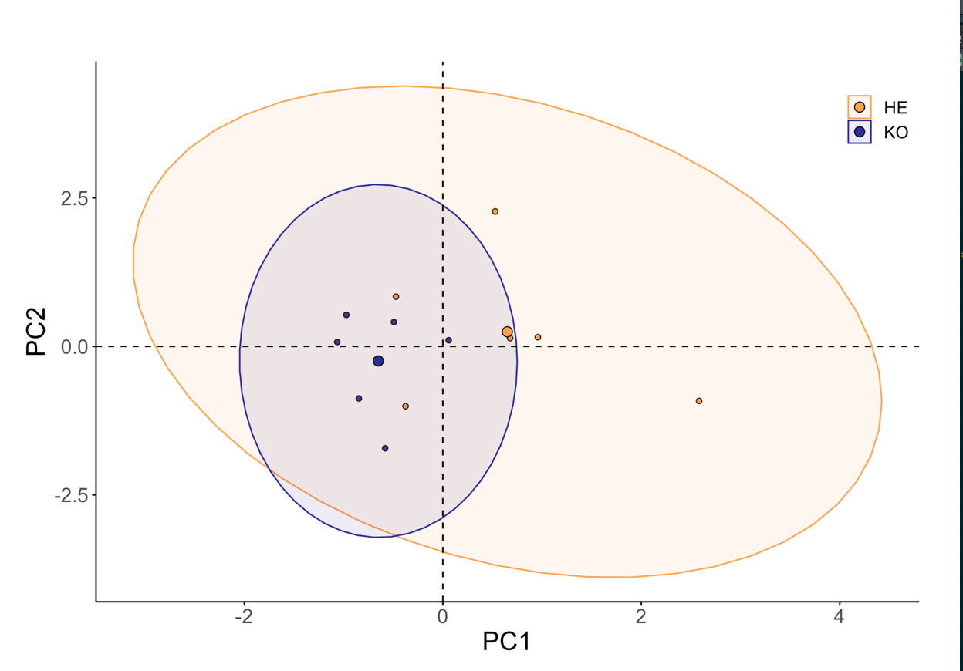

**7.x Ordination of only 2019 measurements**

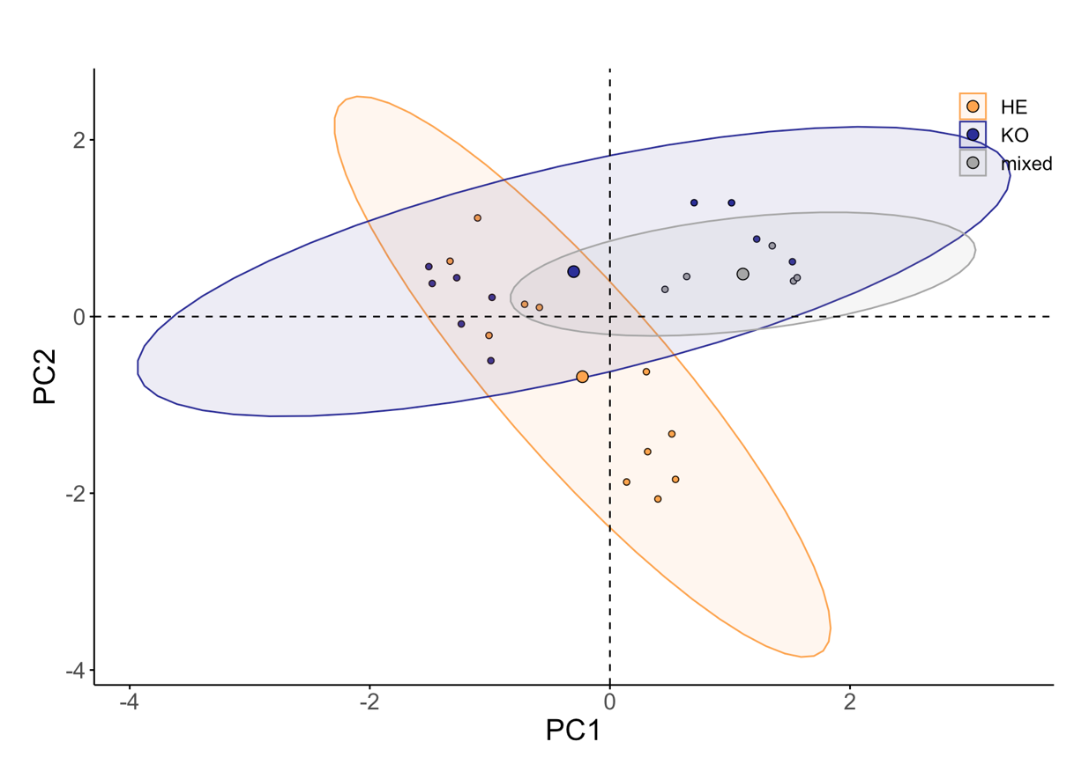

**7.x Post hoc alternate InStability Index (ISI) of bands across the spectrum, only using 2019 spectral signature, with more distinct endmembers**



**Figure 7.x Post hoc alternate InStability Index (ISI) of bands across the spectrum.** ISI values indicate how well bands discriminating vegetation types, with low values being more discriminative. Clear dots along the plotted ISI and the corresponding rugs indicate bands selected, via local minima selection. Background colors correspond to each region of the spectrum; blue 400-500 nm, green 500-600 nm, red 600-680 nm, near infra-red 680-800, infra-red 800-985.

**Table 7.x** Summary of alternate band selection ISI values by region,

|  |  |  |  |  |
| --- | --- | --- | --- | --- |
| Region | ISI | Mean ISI | Number of bands selected | Selected band ISI |
| Blue | 1161 | 21 | 6 | 125 |
| Green | 1044 | 18.3 | 2 | 38 |
| Red | 799 | 18.2 | 1 | 19 |
| NIR | 1326 | 18.9 | 3 | 56 |
| IR | 2218 | 20.8 | 13 | 270 |

**7.x Spectral diversity by Richness, evenness, and bare ground**

Coefficients:

Estimate Std. Error t value Pr(>|t|)

typeHE 0.092751 0.025274 3.670 0.00321 **

typeKO 0.088424 0.028747 3.076 0.00961 **

year2019 0.187232 0.027709 6.757 2.02e-05 ***

richness 0.054068 0.020584 2.627 0.02211 *

evenness -0.003222 0.029593 -0.109 0.91510

bareground -0.028781 0.040306 -0.714 0.48886

typeKO:richness -0.052562 0.046501 -1.130 0.28041

typeKO:evenness 0.031668 0.052830 0.599 0.56003

typeKO:bareground 0.008350 0.046165 0.181 0.85949

**7.x Correlation plot between continuous variables in multiple linear regression model**



**7.x Correlation plot between spectral signatures and all environmental factors derived from point framing data and**



**7.x PCA of spectral signatures and all environmental factors derived from point framing data and**



**7.x Environmental factor biplot**



**7.x Environmental factor biplot by year**

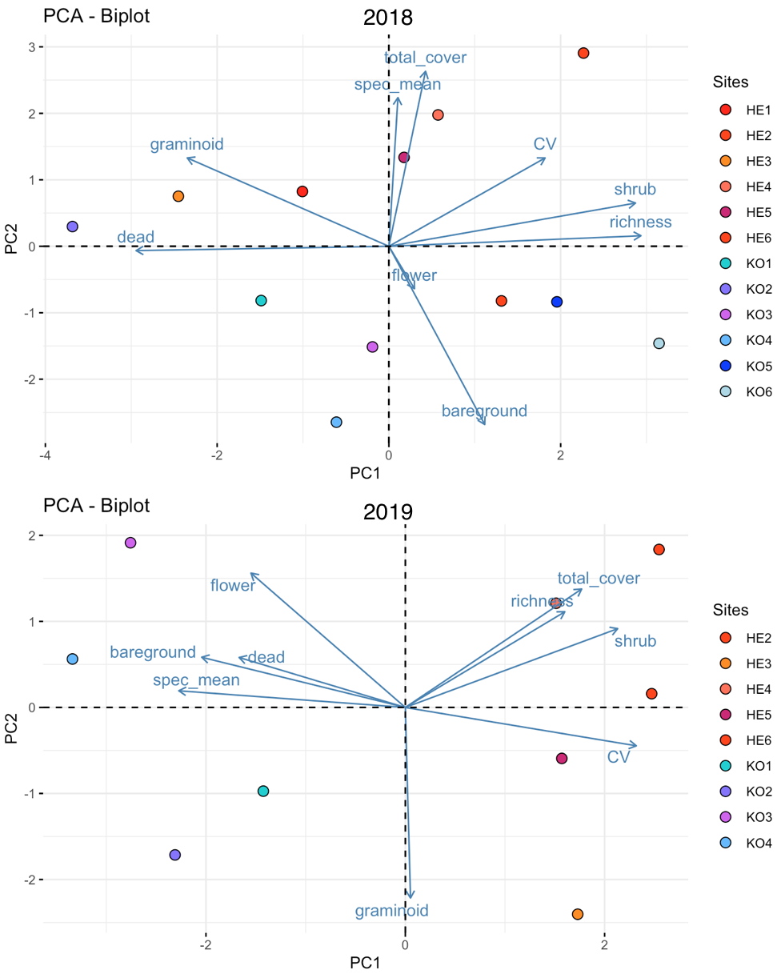

**7.x Bare ground mean reflectance**

stimate Std. Error t value Pr(>|t|)

typeHE 0.04381 0.01450 3.021 0.01064 *

typeKO 0.06390 0.01649 3.874 0.00221 **

year2019 0.06842 0.01590 4.303 0.00103 **

richness -0.01414 0.01181 -1.197 0.25427

evenness 0.02464 0.01698 1.451 0.17236

bareground 0.04492 0.02313 1.942 0.07595 .

typeKO:richness 0.01775 0.02668 0.665 0.51849

typeKO:evenness -0.02679 0.03031 -0.884 0.39409 .

typeKO:bareground -0.05472 0.02649 -2.066 0.06112 .

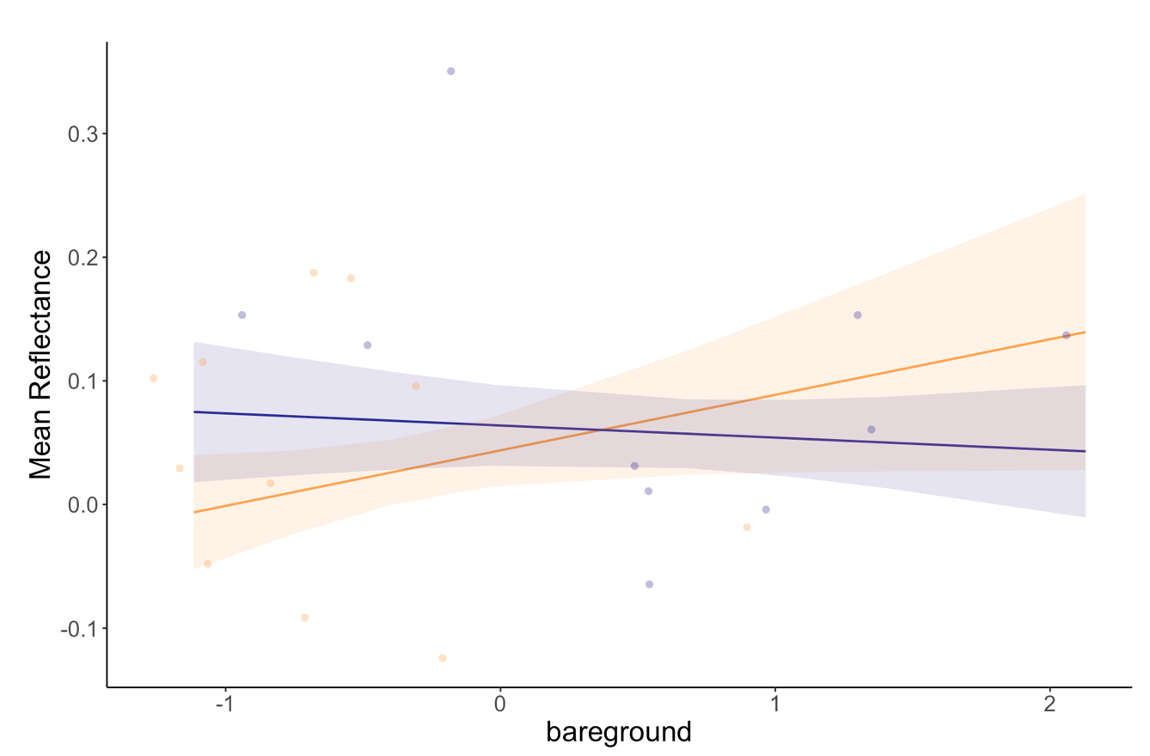

**7.x Code for point framing**

**7.x Code for**

**7.x Packages used for all code**

For full code visit: https://github.com/schneidereits/Dissertation

**References:**

(ArcticDEM, 2018)